Tutorial 15 – Login, Authentication, Assertion & Exception Handling
Screenshot Report
Field | Details
Website / Tool | SauceDemo
URL | https://www.saucedemo.com
Module | Login / Authentication
Student Task | Automate login testing with assertions and exception handling and execute LOGIN01-LOGIN10.
Test Cases | Same TC IDs as the test case sheet: LOGIN01 to LOGIN10
Tester Name | [Your Name]
Enrollment No | ENROLLMENT_NO
Execution Date | [DD/MM/YYYY]
Environment | Windows 10/11, Google Chrome (latest), internet connection

Test Case Execution

LOGIN01 – Valid login
TC ID | LOGIN01
Test Case | Valid login
Test Data | standard_user / secret_sauce
Expected Result | Products page opens (URL contains 'inventory')
Actual Result | Products page opened
Status | PASS
Python Code Screenshot | 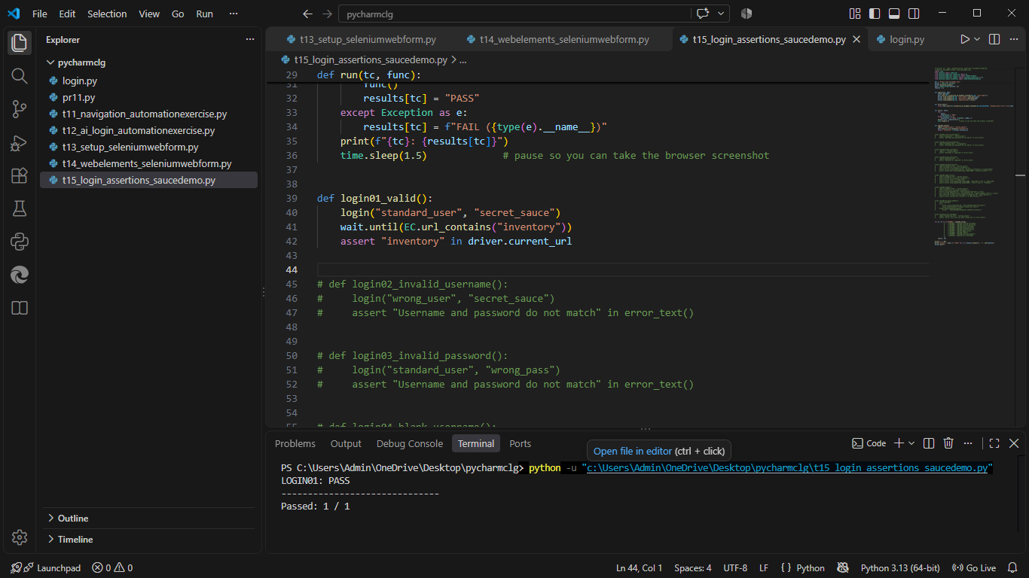
Browser Execution Screenshot | 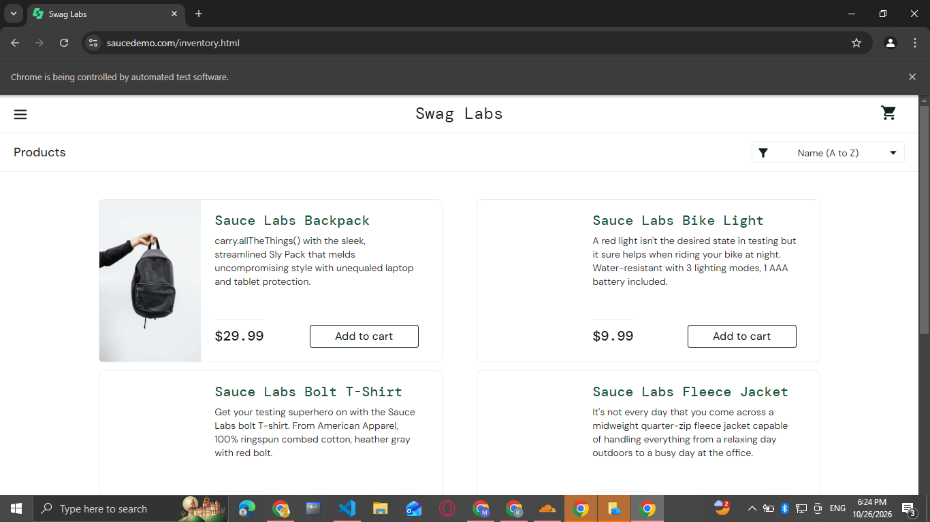
Defect ID | N/A

LOGIN02 – Invalid username
TC ID | LOGIN02
Test Case | Invalid username
Test Data | wrong_user / secret_sauce
Expected Result | Error 'Epic sadface: Username and password do not match any user in this service'
Actual Result | Error displayed
Status | PASS
Python Code Screenshot
Browser Execution Screenshot | 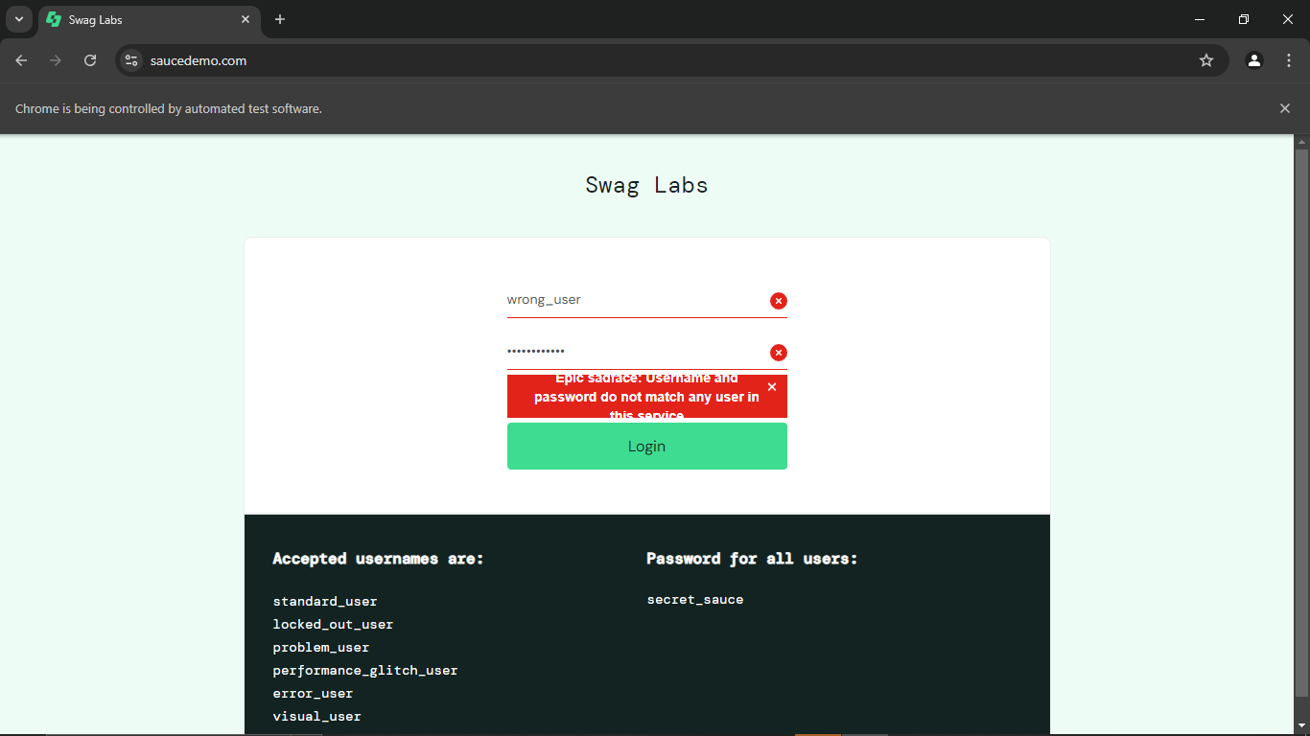
Defect ID | N/A

LOGIN03 – Invalid password
TC ID | LOGIN03
Test Case | Invalid password
Test Data | standard_user / wrong_pass
Expected Result | Error 'Epic sadface: Username and password do not match any user in this service'
Actual Result | Error displayed
Status | PASS
Python Code Screenshot | 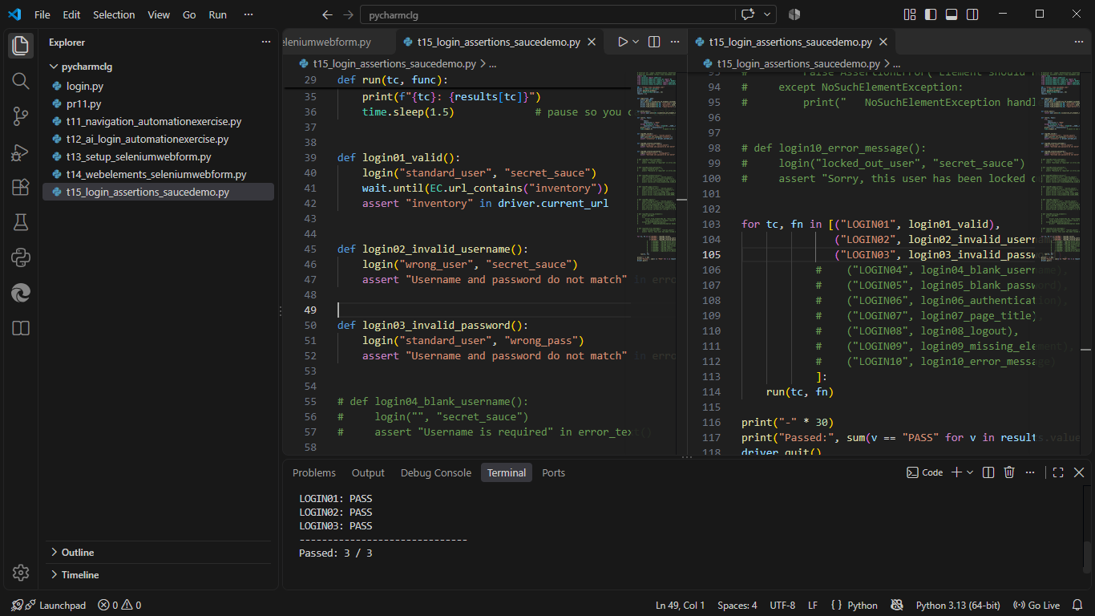
Browser Execution Screenshot | 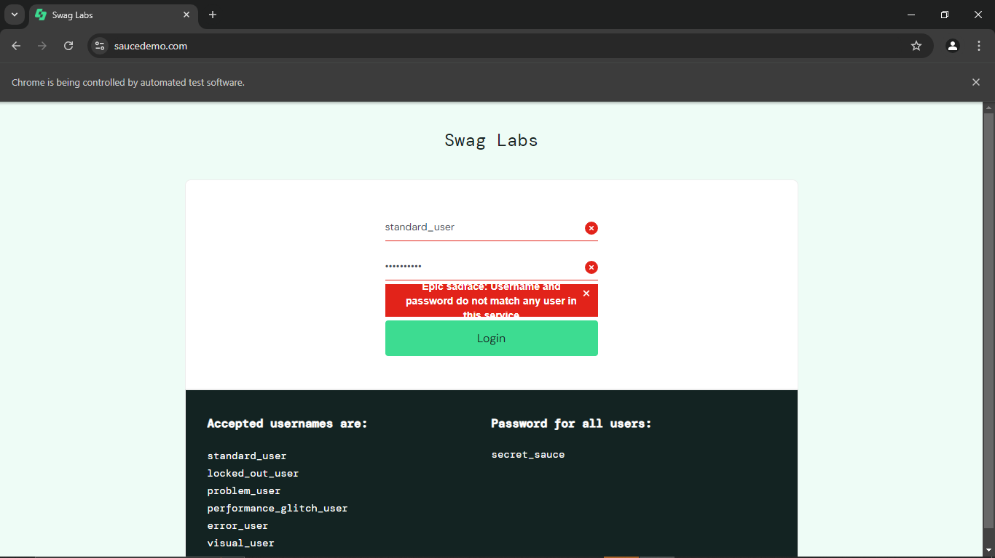
Defect ID | N/A

LOGIN04 – Blank username
TC ID | LOGIN04
Test Case | Blank username
Test Data | (blank) / secret_sauce
Expected Result | Error 'Epic sadface: Username is required'
Actual Result | Error displayed
Status | PASS
Python Code Screenshot | 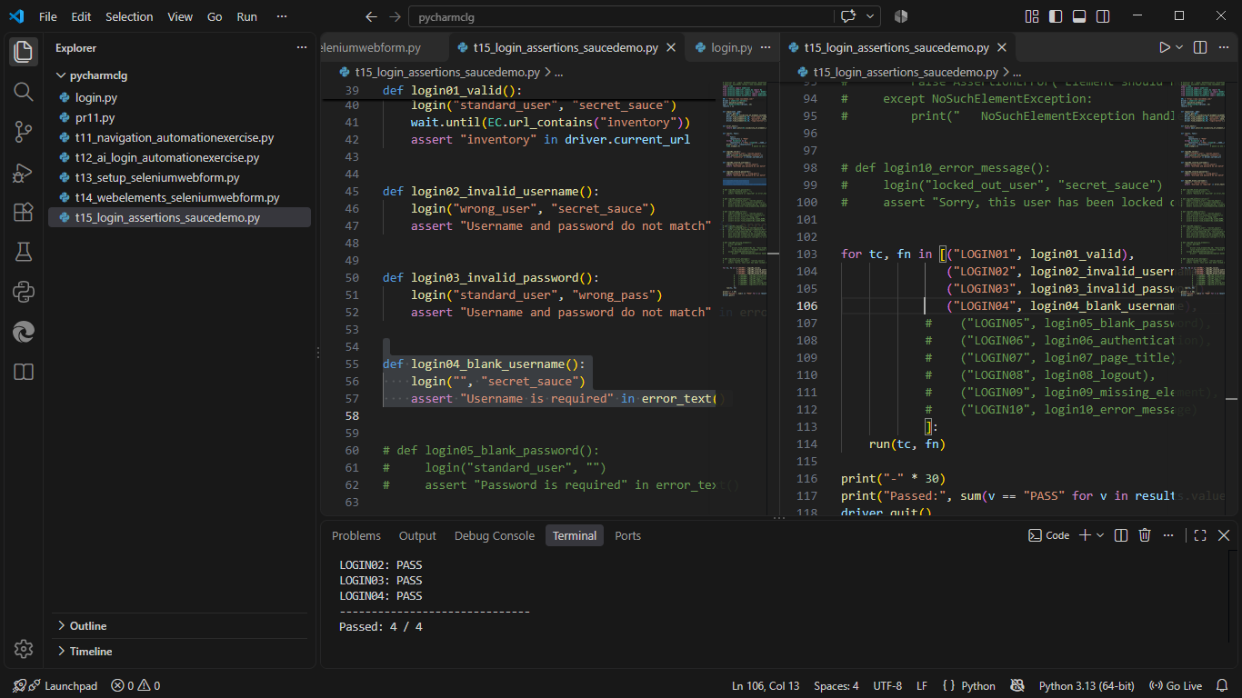
Browser Execution Screenshot
Defect ID | N/A

LOGIN05 – Blank password
TC ID | LOGIN05
Test Case | Blank password
Test Data | standard_user / (blank)
Expected Result | Error 'Epic sadface: Password is required'
Actual Result | Error displayed
Status | PASS
Python Code Screenshot
Browser Execution Screenshot | 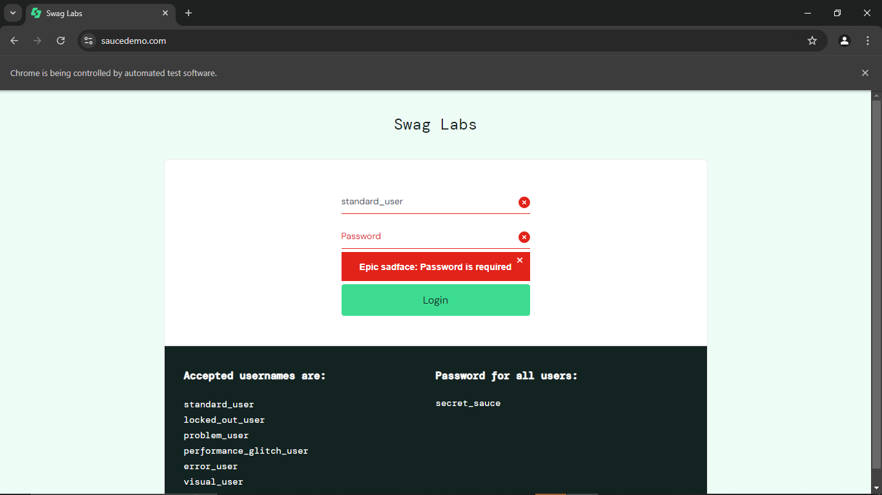
Defect ID | N/A

LOGIN06 – Verify successful authentication
TC ID | LOGIN06
Test Case | Verify successful authentication
Test Data | standard_user / secret_sauce
Expected Result | Inventory container and products are displayed
Actual Result | Products listed
Status | PASS
Python Code Screenshot | 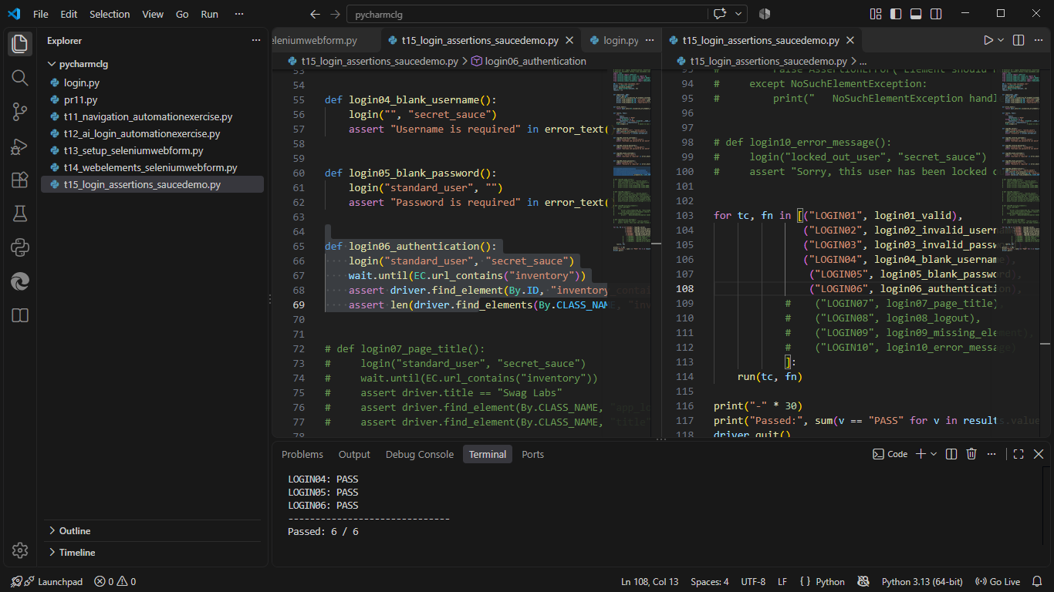
Browser Execution Screenshot | 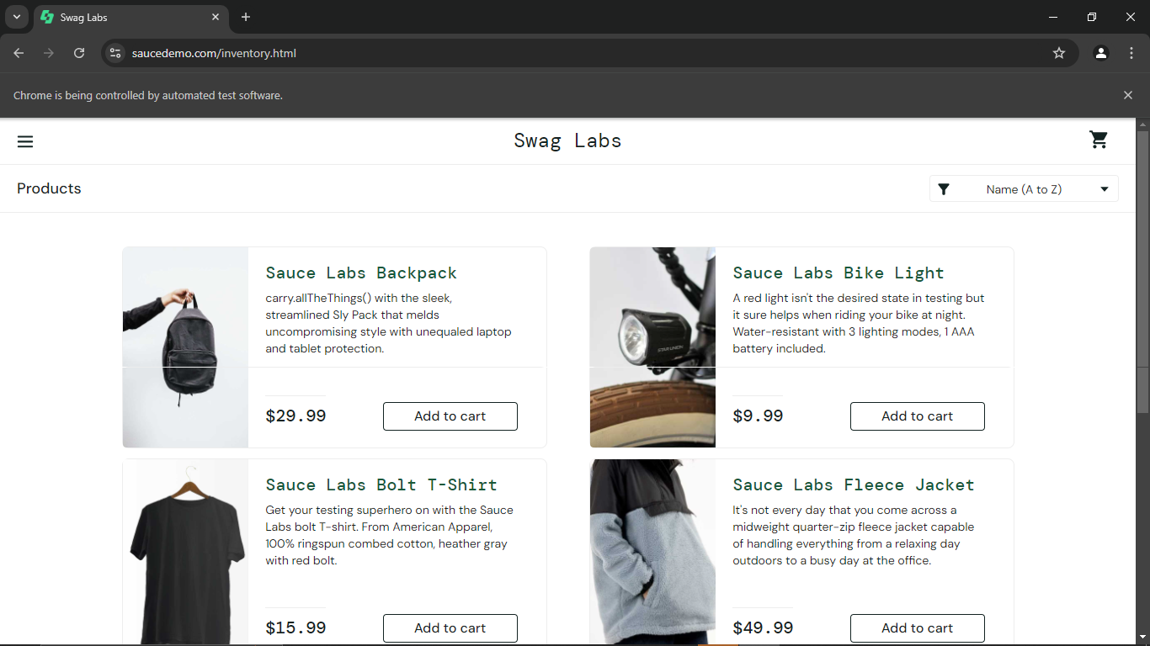
Defect ID | N/A

LOGIN07 – Verify page title using assertion
TC ID | LOGIN07
Test Case | Verify page title using assertion
Test Data | Expected title: Swag Labs
Expected Result | Title is 'Swag Labs' and the header shows 'Products'
Actual Result | Title 'Swag Labs'; header 'Products'
Status | PASS
Python Code Screenshot | 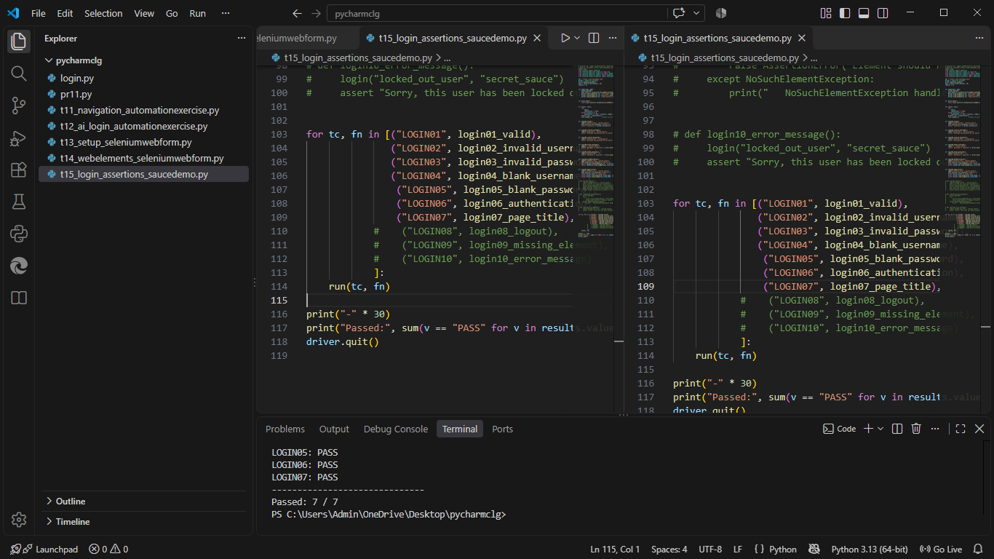
Browser Execution Screenshot
Defect ID | N/A

LOGIN08 – Verify logout
TC ID | LOGIN08
Test Case | Verify logout
Test Data | Menu > Logout
Expected Result | Login page is displayed again
Actual Result | Login page displayed
Status | PASS
Python Code Screenshot | 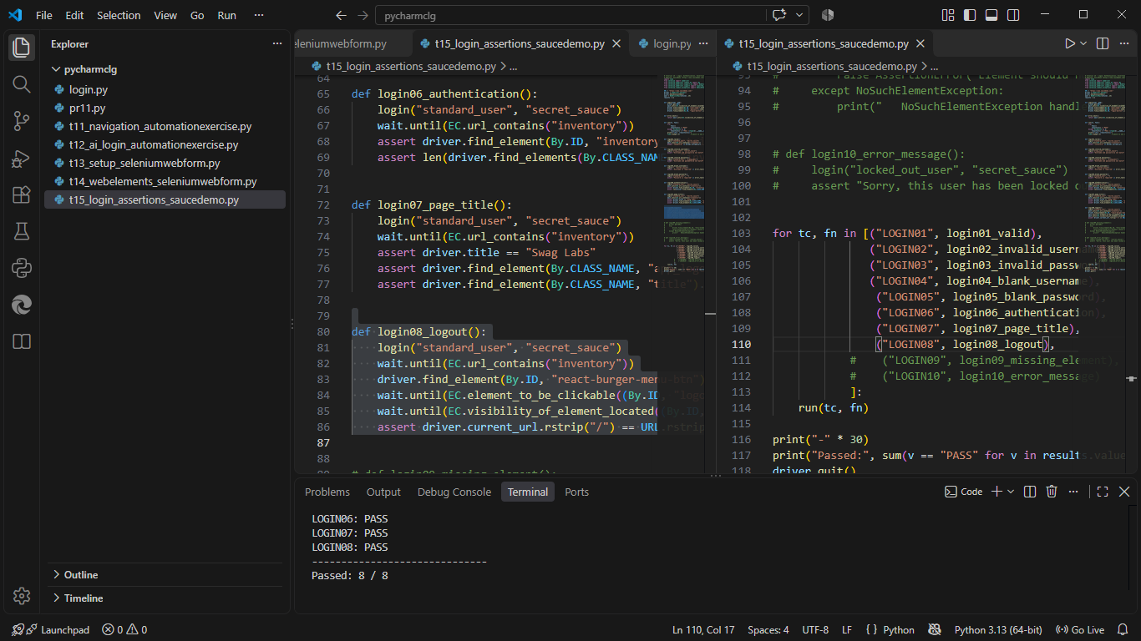
Browser Execution Screenshot | 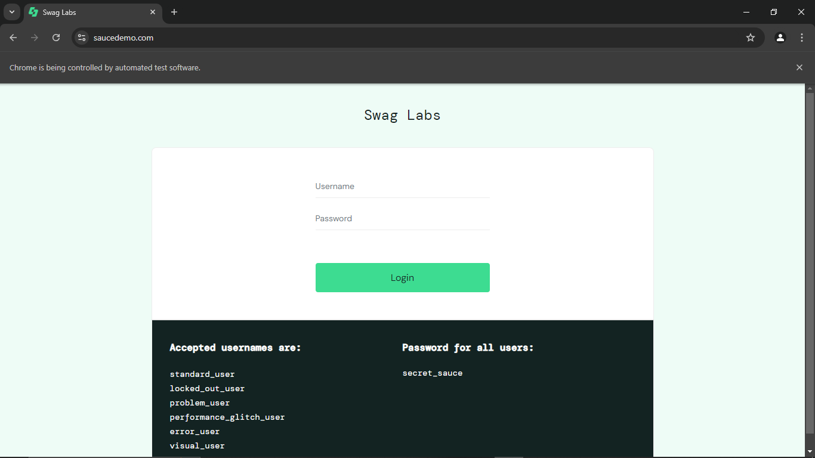
Defect ID | N/A

LOGIN09 – Handle missing element exception
TC ID | LOGIN09
Test Case | Handle missing element exception
Test Data | Element id: this-element-does-not-exist
Expected Result | NoSuchElementException is caught and the script continues
Actual Result | Exception caught and handled
Status | PASS
Python Code Screenshot | 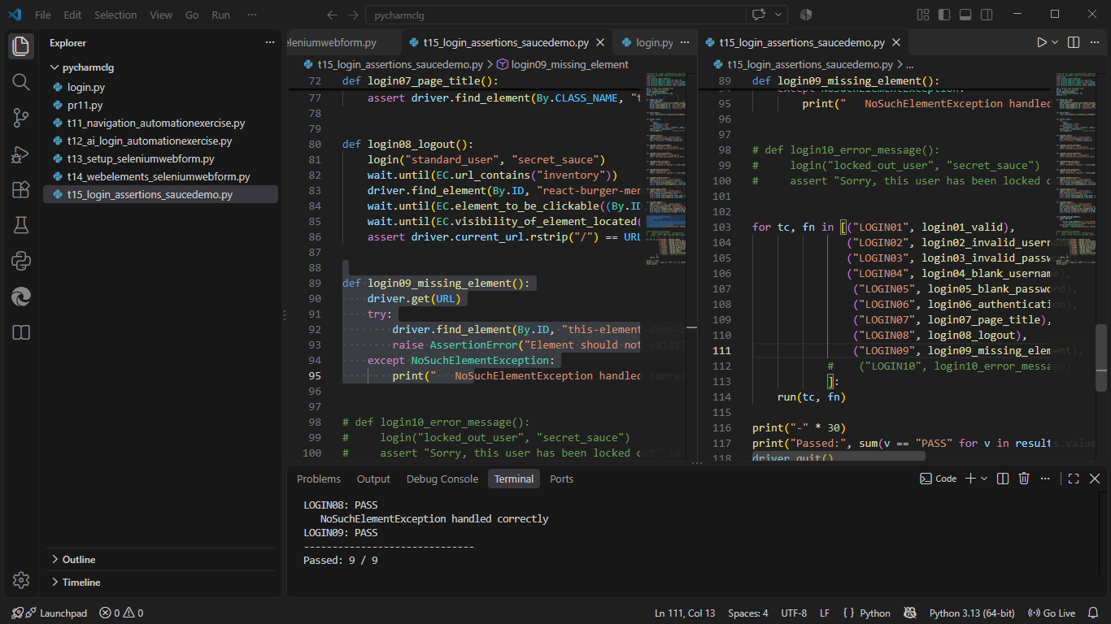
Browser Execution Screenshot | 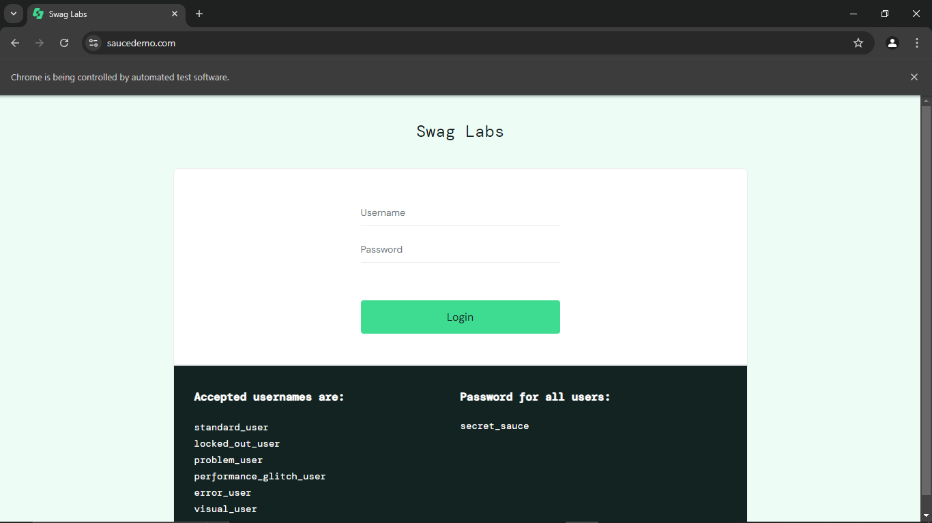
Defect ID | N/A

LOGIN10 – Verify error message (locked-out user)
TC ID | LOGIN10
Test Case | Verify error message (locked-out user)
Test Data | locked_out_user / secret_sauce
Expected Result | Error 'Epic sadface: Sorry, this user has been locked out.'
Actual Result | Error displayed
Status | PASS
Python Code Screenshot | 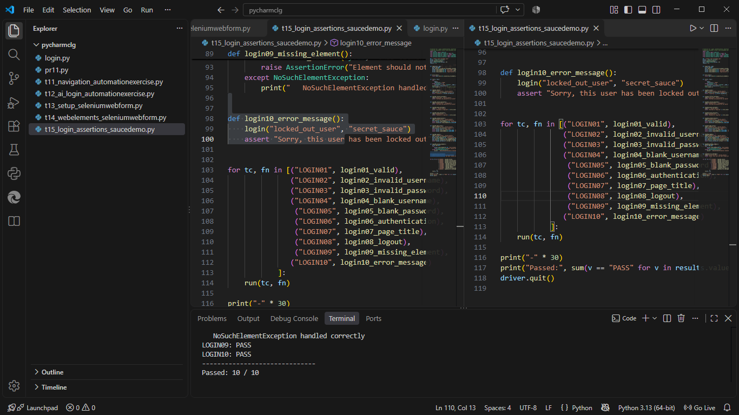
Browser Execution Screenshot | 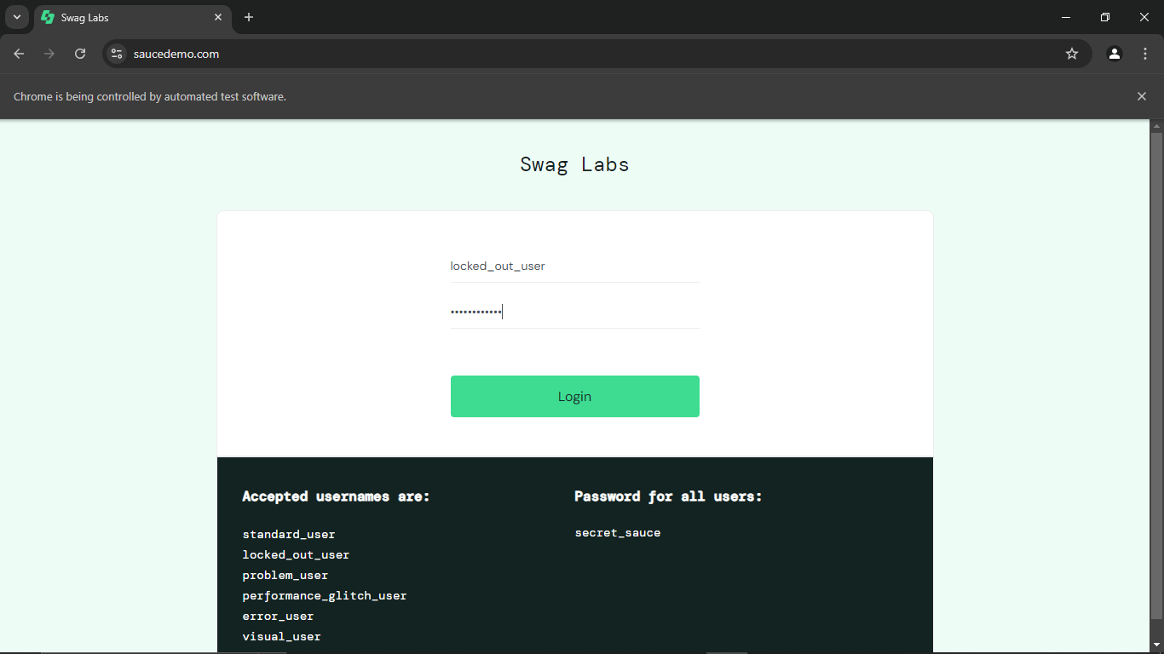
Defect ID | N/A

Locators used in t15_login_assertions_saucedemo.py
TC ID | Web Element | Locator Used in the Script
LOGIN01 | Username / Password / Login | By.ID "user-name" / "password" / "login-button"
LOGIN02-05,10 | Error message | By.CSS_SELECTOR "h3[data-test='error']"
LOGIN06 | Inventory container | By.ID "inventory_container"
LOGIN07 | Page header | By.CLASS_NAME "app_logo" / "title"
LOGIN08 | Menu / Logout | By.ID "react-burger-menu-btn" / "logout_sidebar_link"
LOGIN09 | Missing element | By.ID "this-element-does-not-exist"

Test Execution Summary
Metric | Value
Total Test Cases | 10
Passed | 10
Failed | 0
Blocked | 0
Not executed yet (fill after running) | 0
Pass % | 100.0%

Counts are based on the draft statuses above; update them after you confirm each result.

